Splash Box
Design Guidelines

Carlos Santos-Ramos (Combustion COP)

December 2010
Issued by
DPC

Table of contents

1. Splash Box Design Criteria 3
1.1 Function 3
1.2 Design Criteria 3
1.3 Comparison of Designs from Suppliers 4
1.4 Flap Design 5
1.5 Chute Design 5
2. Reference Documents 5

- Splash Box Design Criteria

  - Function
The splash boxes are devices placed in a cyclone preheater that must guarantee a proper dispersion of the material coming from an upper stage (or the fresh feed) into the gas stream. The material repartition obtained must guarantee the best possible heat exchange and must avoid the fall of material directly to the lower cyclone (material by-pass) assuming that gas to be of adequate velocity and well distributed profile.
  - Design Criteria
Splash boxes
- must be placed in all preheater stages where the material is injected into the gas stream, perpendicularly to the gas flow to promote the best dispersion; not applicable in the smoke box and in some precalciners (according to the design);
- cleaning operations must be facilitated:
- poking holes must be well oriented and have a fast and safe closing device,
- air blasters can be used in normal operation,
- continuous air cleaning systems must be avoided,
- the area must be easily accessible and with at least two access routes;
- the position should be high enough to let the gas going out from the previous stage to be well developed; the recommended distance from the splash box to the bottom of the cyclone vortex finder (also known as thimble or skirt) is 1,4 times the duct diameter (minimum 2m and at least 0.5m above the cyclone roof); for precalciners at least a distance of 1 duct diameter from the last direction change;
- they have to be oriented in the duct axis; in case of twin cyclones, the splash boxes must be opposite facing;
- the meal feed pipe axis must be inclined at least 60° to the horizontal plane (up to 70° for fresh feed injection);
- a free distance of a least 2,5m must be respected from the last elbow or flap to guarantee a proper material speed and distribution at the splash box;
- the axis of the chute should cut the prolongation of the vertical tube at the concreted splash box bottom or up to 250mm in the inlet of the splash box.

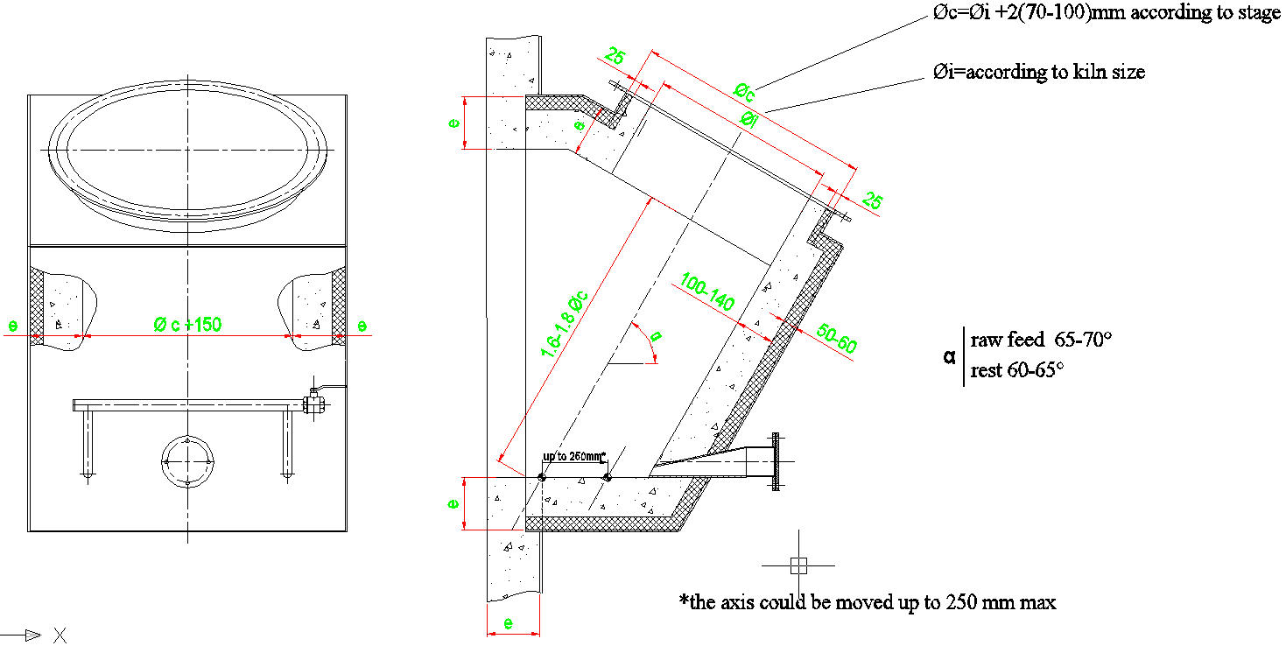

  - Comparison of Designs from Suppliers
Criteria | Angle | Width | Height | Chute Axis Position | Bottom
Lafarge | 60°-70° | φ chute + 150mm up to 15° openness | 1.8-2.0 chute φ | -250-0mm to the inside steel angle | Flat
Technip | 60°-70° fresh feed | φ chute + 100mm | 1,9 chute φ  1,8 for fresh feed | -15mm to the inside steel angle;  -55 for fresh feed | Flat
CBMI | 60° | φ chute + 100mm | 1,8-2,0 Chute φ | to the inside steel angle | Flat
Polysius | 65° |  | 2,25 Chute φ | to the inside steel angle | Flat
Kawasaki | 60° | φ chute + 100mm | 2,0 Chute φ | at the concrete angle | Flat
KHD | 55° | idem chute | 1,5-1,6 Chute φ | at the concrete angle | Flat

  - Flap Design
- each transfer must be provided with a flap to prevent gas bypass to the upper stage;
- the flap has to respect the section for the material chute (including refractory);
- they must be protected with refractory, anti-abrasive concrete (for the lower stages in both sides) when T is expected to be >600°C;
- they can be adjusted (counterweight system);
- two flaps must be provided for the upper cyclone(s) discharge;
- a rotary air lock must be provided for the fresh feed;
- in vertical chutes double flaps are preferred to single ones, but for inclined chutes only single ones must be used;
- to promote a proper impact of the material in the flap, a minimum free distance of 2,5m before it must be respected.

  - Chute Design

Preheater size [t/d] | Material chute effective diameter [mm]
Preheater size [t/d] | Top Cyclone | Intermediate Cyclones | Bottom Cyclone
1000-1500 | 350 | 450 | 550
1500-2000 | 400 | 500 | 600
2000-2650 | 450 | 550 | 650
2650-3200 | 500 | 600 | 700
3200-3600 | 550 | 650 | 750
3600-4000 | 600 | 700 | 800

- Reference Documents
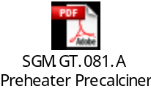CTEO Preheater-Precalciner mechanical technical specification:
CTEO Flap valves mechanical technical specification:
TCEA splash box design:
CTEC splash box design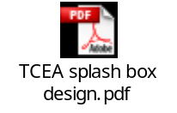:
Technip:
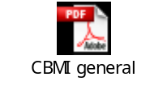CBMI :
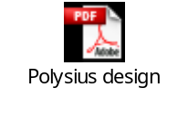Polysius:
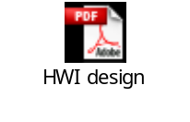KHD:

Angle formed by the meal feed pipe and the horizontal plane

